# HTML and CSS

## EXERCISE 1: BASIC HTML

This task is concerned with familiarising yourself with the basic features of HTML. Using the files available in the archive **basic-html-task.zip** you must create two web pages as described below. In order to find out how to achieve these things, refer to the HTML tutorial and reference at <http://ww.w3schools.com/html>.

Pay attention to the text of the web pages you are creating: in some places it tells you what to do.

To edit the HTML files you should use the program **NotePad++** which is available on all lab machines. It is much better than the basic Notepad program in windows. (NotePad++ is free software: you can download and install it on your own computer from <https://notepad-plus-plus.org/>).

You can create these pages locally on your own PC but once it has been done you must upload the pages and associated files to your Daydream web server account. See separate document for details of accessing your Daydream account, uploading files with FileZilla and viewing the site in a web browser.

Create this page in a file called **firstpage.html**.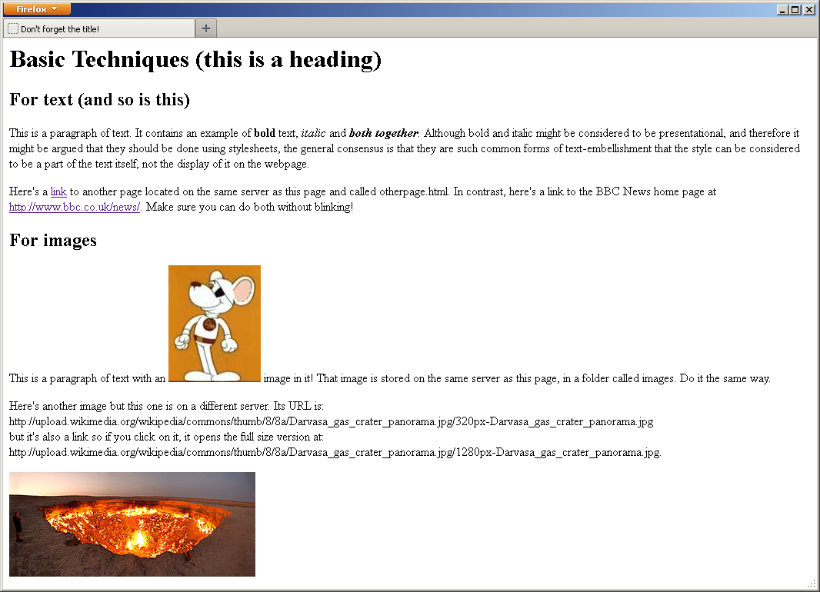

Create this page in a file called **otherpage.html**.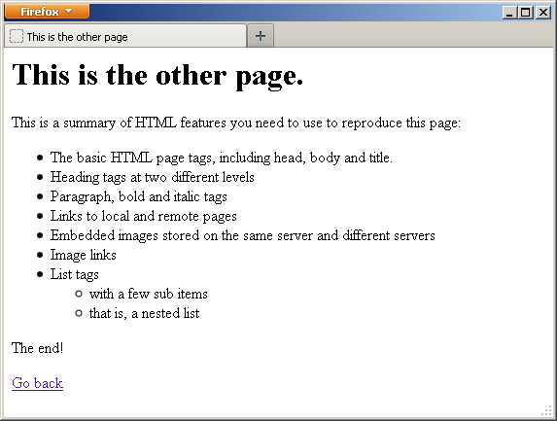

For your convenience, all the text required is provided below in a format suitable for copying:

Basic Techniques (this is a heading)

For text (and so is this)

This is a paragraph of text. It contains an example of bold text, italic and both together. Although bold and italic might be considered to be presentational, and therefore it might be argued that they should be done using stylesheets, the general consensus is that they are such common forms of text-embellishment that the style can be considered to be a part of the text itself, not the display of it on the webpage.

Here's a link to another page located on the same server as this page and called otherpage.html. In contrast, here's a link to the BBC News home page at http://www.bbc.co.uk/news/. Make sure you can do both without blinking!

For images

This is a paragraph of text with an image in it! That image is stored on the same server as this page, in a folder called images. Do it the same way.

Here's another image but this one is on a different server. Its URL is:

http://upload.wikimedia.org/wikipedia/commons/thumb/8/8a/Darvasa_gas_crater_panorama.jpg/320px-Darvasa_gas_crater_panorama.jpg

but it's also a link so if you click on it, it opens the full size version at:

http://upload.wikimedia.org/wikipedia/commons/thumb/8/8a/Darvasa_gas_crater_panorama.jpg/1280px-Darvasa_gas_crater_panorama.jpg.

This is the other page.

This is a summary of HTML features you need to use to reproduce this page:

The basic HTML page tags, including head, body and title.

Heading tags at two different levels

Paragraph, bold and italic tags

Links to local and remote pages

Embedded images stored on the same server and different servers

Image links

List tags

with a few sub items

that is, a nested list

The end!

Go back

|  |
| --- |
| **EXERCISE 1: BASIC HTML** |
| ***Required in your report (basic exercise).*** |
| A brief written description of each of the following, including the code you used and explanation of how the similar things are different to each other:   * Making a link to the second page, that is a page on the same web server. * Making a link to a page on a different web server (BBC news). * Including an image in your page when the image is on your own web server (the picture of the mouse). * Including an image in your page when the image is on another web server (the volcano) * Making an image into a clickable link.   Also include:   * A clickable link to the completed web page in your Daydream account. * Reflection on the tasks and all activities involved. |
| ***Extended Tasks*** |
| * Add a numbered list to the second page. * Add an HTML table to the second page. * If your Meno account is active, make a web page for your Meno webserver and which links to the page you have on your Daydream server, and make the page on Daydream server link back to that. |
| *Additional work: investigate and experiment with any related subject matter that interests you.* |